HTML GRAPHICS - Using Canvas
Additional Task – (LO3) – Assignment (Task 3)
Visit - https://www.w3schools.com/html/html5_canvas.asp
Try some of the examples on the page
For this task you are required to create the following rectangle logo below
You decide on font, size, border thickness and rectangle width & height
Jo Smith

Screenshot w3schools code with completed rectangle logo here
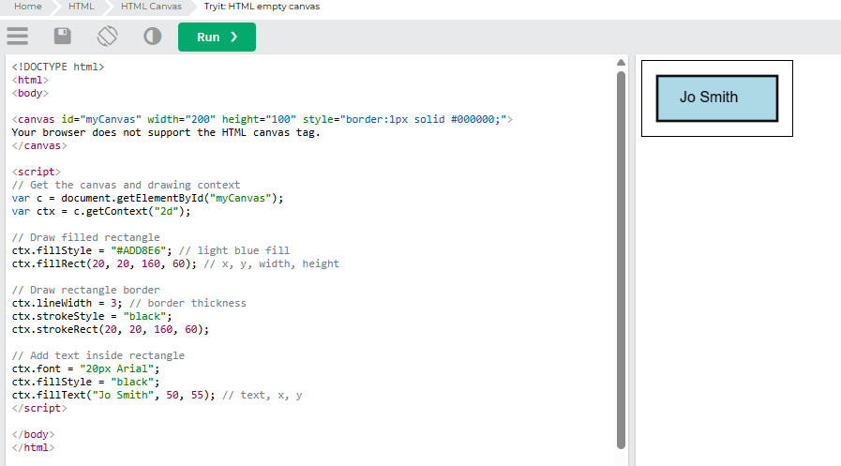

HTML GRAPHICS - Using SVG
Additional Task – (LO3) – Assignment (Task 3)
Visit - https://www.w3schools.com/html/html5_svg.asp
Try some of the examples on the page
For this task you are required to create the following oval logo below

JS
You decide on font, size, border thickness and oval width & height
Screenshot w3schools code with completed logo here
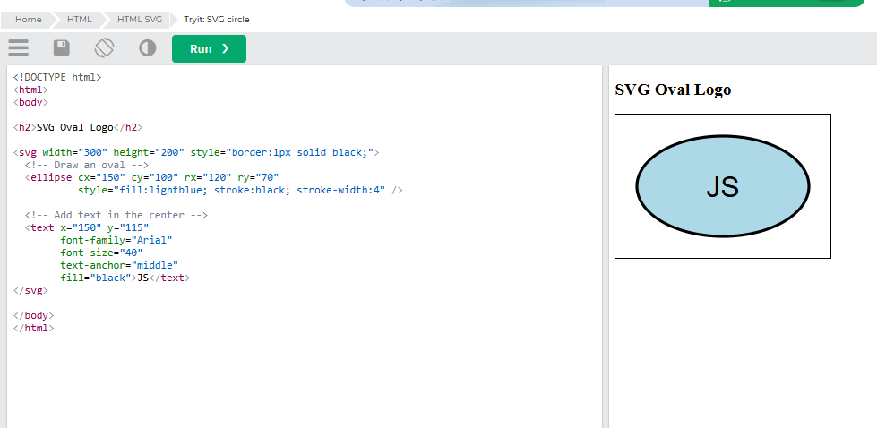

Save to docs sub-folder & submit to Canvas on completion

